ROBOTIC ARM CONTROL WITH AI
Kenneth Aarón Martínez Lazo
Universisad del Pais Vasco
Student
Bilbao, Spain
kmartinez020@ikasle.ehu.eus

Abstract—This project delves into the control of robots, in particular robotic arms and their kinematic models as well as the implementation of machine vision with the purpose of proving the theoretical concepts and tools used in the manufacturing industry.
Keywords—kinematic, Machine Vision

Introduction
In the field of industrial robotics, there are many different settings and environments in which to develop a suitable solution for object manipulation. In most cases, the most flexible and widely available solution is the use of robotic arms; therefore, it is inherently vital for future engineers to understand the basics of how such robots are made, controlled, and improved. Based on the current growth in the use of collaborative robots in SME manufacturing and the demand for low-cost vision-guided automation, this paper involves the development of a mechanical structure based on existing robot arms and its interaction with the environment, covering manipulation, control, and machine vision. The main objectives are to showcase an understanding of the basic concepts and their implementation in real-life problems, as well as to integrate low-cost, easy-to-control robots. This project revolves around an RRR (three chained revolute joints) robot with a gripper actuator and a camera for object identification, using open-source programs and environments such as the Arduino IDE, Raspberry Pi OS, and OpenCV, coupled with custom hardware made by the authors of this paper.

Engineering A Solution
Given the task of building a cheap and easy to control robot with AI vision the task at hand must be tackled in the following manner.

Control Problem
1). Simple actuators that are cheap and light like the micro servo motors are widely available and simple to control with PWM signals but at the cost of not being very precise.
2). The need for a flexible controller that can handle control voltages compatible with servo motors and is able to communicate with more specialized hardware usually leads to the ARDUINO microcontroller which is open source and cheap.

Target Detection
One of the most popular software used in Open-Source projects for object detection is OpenCV for which there are many SBC (single board computers) available being the most ubiquitous the Raspberry, which can also communicate via I2C and utilize a camera ports.

Hardware
It will be mandatory to build a small scale arm with links and actuators on the joints attempting to reduce the overall weight and increase the sturdiness of the robots in any way possible. Additionally, it may be possible to build a breakout board for the I2C communication, due to the differences in logic levels of the two boards. Taking these facts into account this paper will attempt to build upon those ideas as described further in the text.

The kinematics
The structure is described as a Three DOF planar, since the chained actuators complete the rotations. It was decided to add a gripper end effector, while this could be changed later on it was also vital to keep the weights as minimal as possible. Therefore, shifting the weight to the base by using a simple transmission.
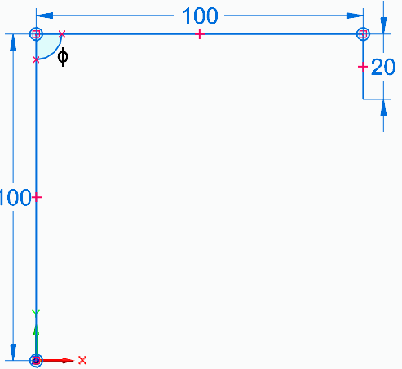
The simplified structure of the Arm goes as follows :

- This is a figure caption. It appears directly underneath the figure.

Where we can observe the two problems to arise, the first one is the position and second one is the rotation.
The positioning problem is solved by defining the inverse kinematics of the structure, using the law of cosines we know the total distance of the target position X and Y is equal to:
$$X^{2}{+Y}^{2}= {L_{1}}^{2}+{L_{2}}^{2}-2L_{1}L_{2}cos⁡(φ)$$
$$\cos\left(φ\right)= \frac{X^{2}{+Y}^{2}- {L_{1}}^{2}-{L_{2}}^{2}}{2L_{1}L_{2}}$$
From this we know we have two options which are elbow up or down:
$θ_{2}=180±acos⁡(φ)$
$$θ_{1}=atan2\left(Y, X\right)-atan2(L_{2}sinθ_{2}, L_{2}cosθ_{2}+L_{1})$$
Its is important to note that the end position of the two-fist links must be at a distance L3 from the target. Thus, when including the third link and its angle the optimal position is reached.
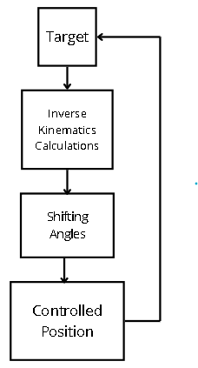
The second one is solved by calculating the chained rotations of the robot:
$$θ_{3}= θ_{123}- θ_{2}- θ_{1}$$
In this case handling objects means we will always point downwards meaning we position the end 20mm above the target and calculate the rotation based on the previous ones to have an absolute rotation of -90 degrees, solving the kinematics.

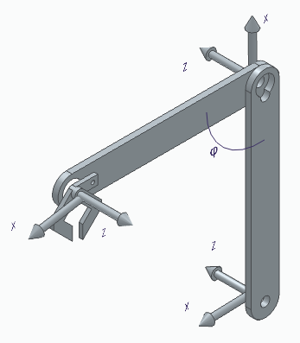
The 3D structure of the arm is the following
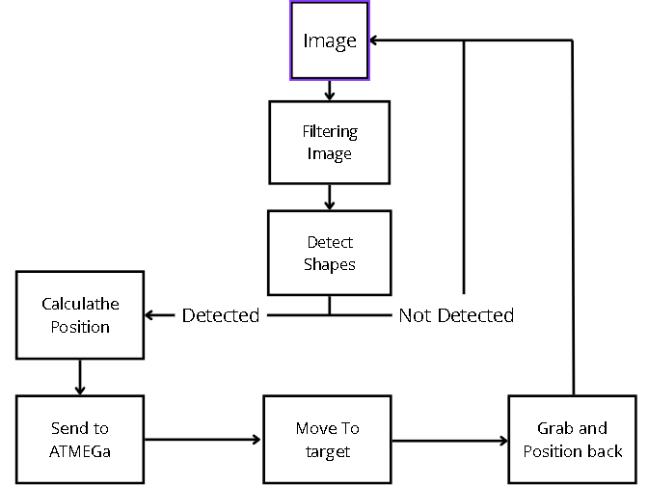
- This is a CAD design with the angles and axi.
To avoid any need for iteration to get the angles the initial configuration and angles is the one described in the picture, with the x axis given the DH parameters and there will be a need to modify the angles of the motors due to the physical location.

Hardware and Software
The basis of the setup are using an Arduino programmed ATMEGA328P and a Raspberry pi Zero 2W SBC, coupled with a Raspi Camera.
Each of the components takes a crucial part on the task in the following manner:

Control
We start with a target position given by the start position or pose of the arm, then the calculations of the kinematics must be performed, in this case preferring the top elbow since the first pose will have one, then we must take into account the differences in between the angles given in the relative positions and the angles on the servos themselves needing to shift those angles to match the one in the DH parameters, and lastly the servo motors that were chosen are controlled via a PWM signal ranging from 1ms to 2ms. These values representing the maximum and minimum rotations, when handled with a library like Servo.h these values are set automatically by using angles instead, these values are set in a ratio such that the changes in velocity are soft and not sudden making the control smooth and predictible. [1]
- Flow diagram of the program (C++)

Target Detection
The first thing to define is the method for identification for which as previously mentioned OpenCV was used, giving the image handling capabilities, it was decided to use a simple color scheme to detect objects in the shape of squares, for this purpose there needs to be a correctly formatted image which is then processed as pixel units with hexadecimal values that identify the colors, then the utilization of shape recognition already included in the libraries, which in term detects the position, rotation and scale of the target as well as two set points, these points will serve as real life marks that have a known distance and size due the relative position of the camera to the arm, this gives a form to calculate the equivalent distance in pixels to the target. [2][3]
- Flow diagram of the program (Python)

Hardware
Previously stated is that the basic structure is simply comprised of two links and a gripper made in wood and a composite of cyanoacrylate and paper. The first two actuators will be positioned at the left side of the arm and the third one in the opposite attempting to correct the distance in the y axis to match the zero of the first revolute joint, additionally, the gripper will me remotely actuated and not directly due to weight constraints.
The control and image capturing with the communication will be made separate from the arm since it must be in short range to the camera and perpendicular to the arm structure. Thus, effectively handling the task of capturing, analyzing and sending target signals, this must be performed through a bidirectional level shifter since the voltage of the Pi Controller is 3V and the Arduino uses 5V, this can be easily archivable using logic level MOSFETS.[4]
Given all the description above, the project was developed and successfully utilized in the detection and manipulation of the target giving the following conclusions.

Conclusions
Following is a table with the different times and precision of this setup, that further demonstrates how realistic the approach was at archiving the task, taking the time from the image capturing and the analysis down to the precision of the positioning of the EE.
- Task performance
Test N° | Task Performance
 | Real position(mm) | Capturing time(s) | Reach Position(mm)
1 | (50, 10) | 6 | (52, 10)
2 | (100, 0) | 5 | (100, 0)
3 | (50, 0) | 5 | (50, 0)
4 | (80, 0) | 4 | (80, 0)
5 | (50, 50) | 5 | (55, 60)
6 | (100, 50) | 6 | (100, 60)

After analyzing many iterations of the imaging and movement process it was decided that the imaging is rather slow compared to fast AI enhanced imaging taking an average of 5 seconds to detect the target and calculate the trajectory.
The other main cause of issues is the instability and lack of precision that the mechanical structure has, given the cheap and handmade links coupled with low quality servos, meaning that the position is on average 5-10 mm off.
But overall, the project validates that practical robotic manipulation systems can be developed with minimal resources while still reflecting core industrial principles. It provides a solid foundation for further exploration in robotics, control systems, and AI-driven automation, particularly in the context of small and medium-sized manufacturing environments.

Acknowledgments
The author of this text would like to thank prof. IZASKUN GARRIDO HERNANDEZ for her tips on the creation of this paper and the tips on the mechanical construction, expressions of the kinematics and overall opportunity to develop this project.
This project could not be at all possible without the help of multiple Open-Source Communities. And is available in GitHub.

References
- Arduino controlled robotic arm, Ankur Bhargava, Anjani Kumar, Guru Gobind Singh Indraprastha University, Delhi, India.
- S. Anjanayya, S. P. Sai, S. S. Vardhan, S. Vivek, A. Vaishnavi and V. Ashwanthi, "Object size measurement using open CV (Computer Vision)," 2023 International Conference on Research Methodologies in Knowledge Management, Artificial Intelligence and Telecommunication Engineering (RMKMATE), Chennai, India, 2023, pp. 1-6, doi: 10.1109/RMKMATE59243.2023.10369151. keywords: {Computer vision;Shape measurement;Semantic segmentation;Quality control;Size measurement;Cameras;Real-time systems;Open cv;Stereo vision;Dimension calculation;Edge detection},
- A. Aurelius, “Python: detect black squares,” Stack Overflow, Aug. 22, 2013. [Online]. Available: https://stackoverflow.com/questions/17883023/python-detect-black-squares. [Accessed:Apr. 2026].
- N. Chauhan, “DIY 4 Channel Bi-directional Logic Level Converter,” Instructables, Oct. 25, 2022. [Online]. Available: https://www.instructables.com/DIY-4-Channel-Bi-directional-Logic-Level-Converter/. [Accessed: Apr. 2026].

